

**UIU MARS ROVER TEAM**

**(Soft. TEAM)**

**Documentation on:** Webpage

**Submitted by- Submitted to-**

Sakib Mahmood Saad Abdullah Al Masud

(Soft Team Lead)

**Date of Submission :** 20/3/2023

**Objective:**

Designing webpage for Autonomous,ESM_ERDM & Science.

**Autonomous Dashboard:**

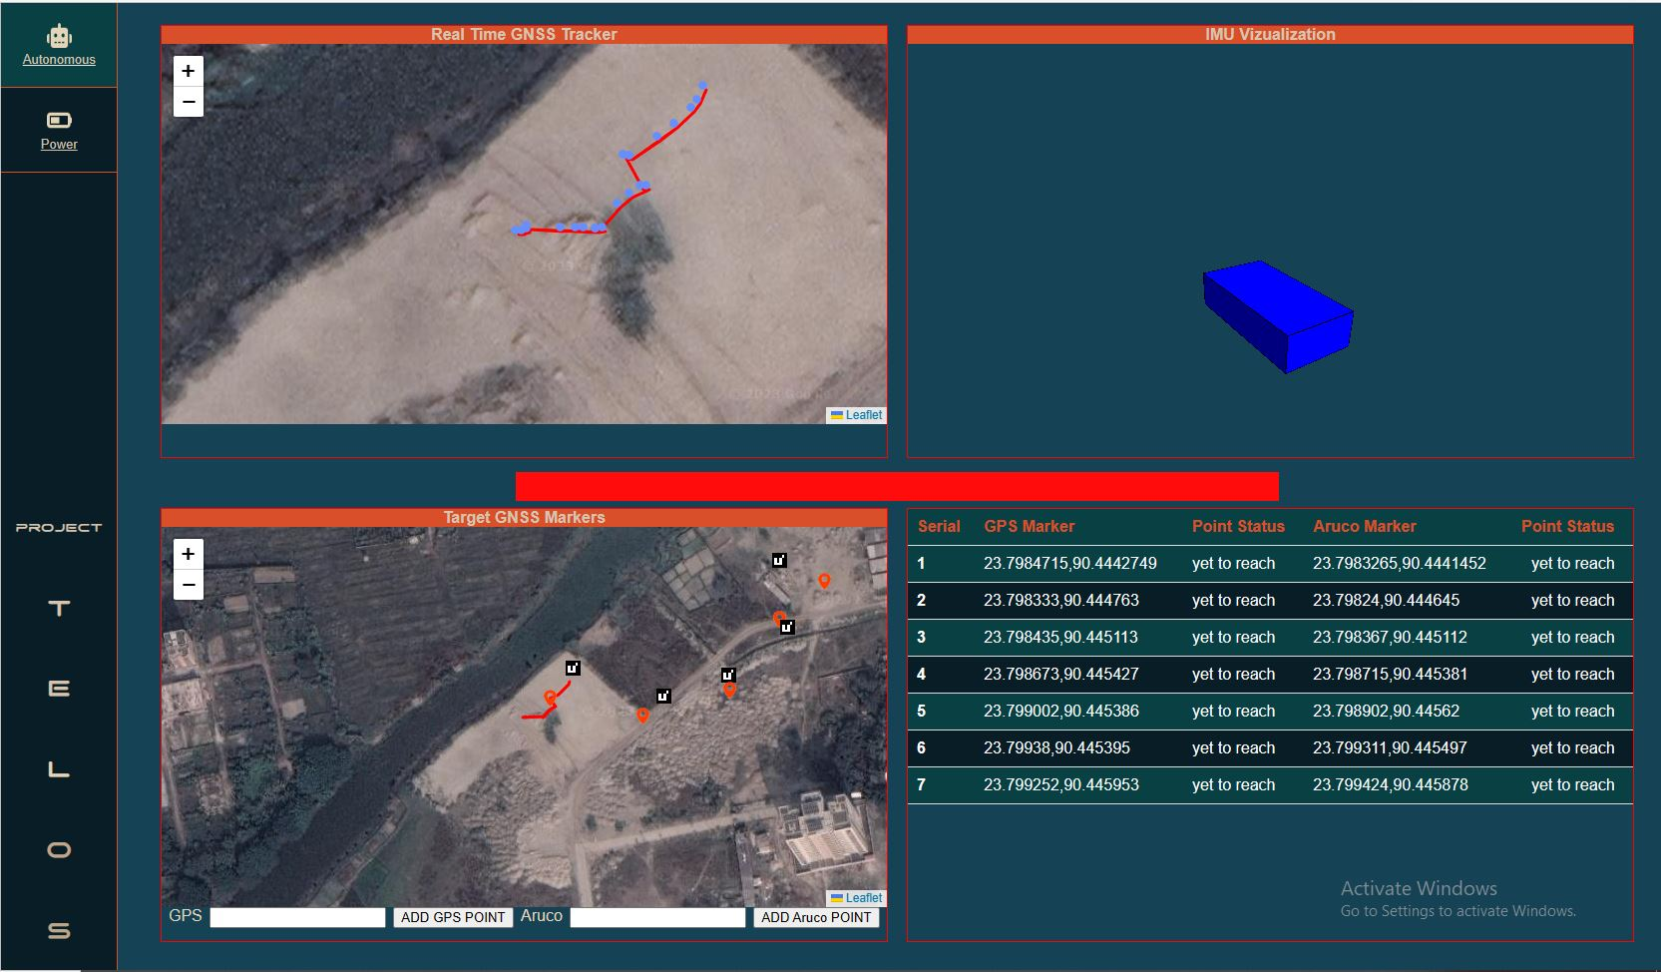

**Real time GNSS tracker:**

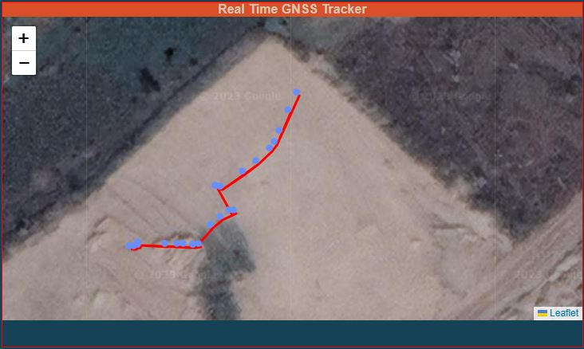

Real time GNSS tracker marks on the map the path that TELOS has traveled.

**Target GNSS Markers:**

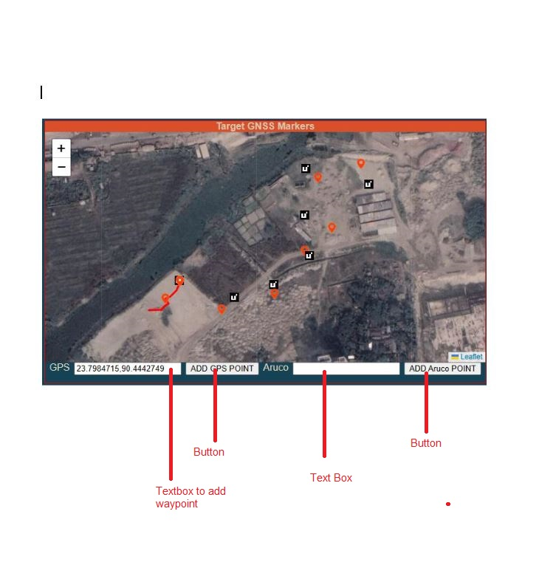

Coordinates of the ArUco markers should be given on the text box and when the button(ADD GPS POINT) is pressed coordinates should be added to the table.

**Coordinate Table:**

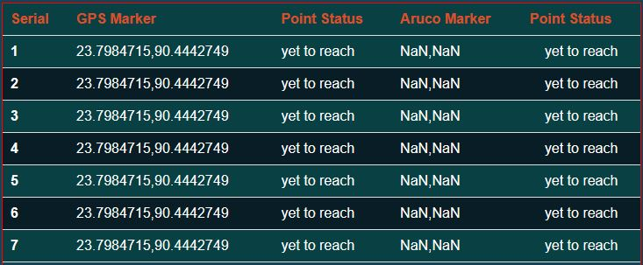

**Blinking light:**



The light keeps blinking red until it reaches the target. Whenever it reaches the target it turns green.

**ESM ERDM Dashboard:**

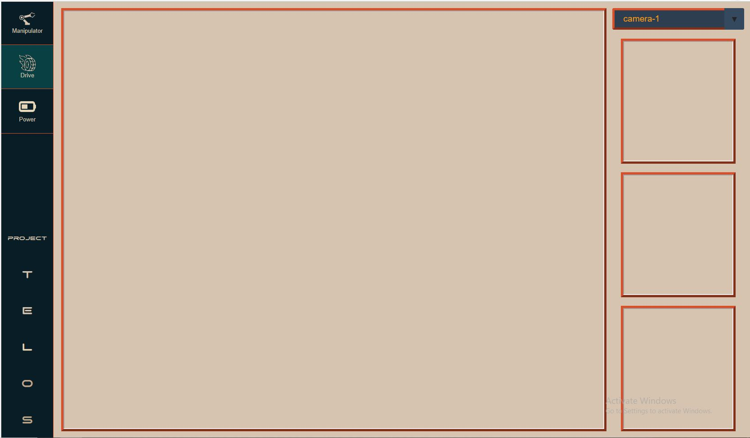

The dashboard consists of 4 camera feeds and cameras can be switched using dropdown.

**Science Dashboard:**

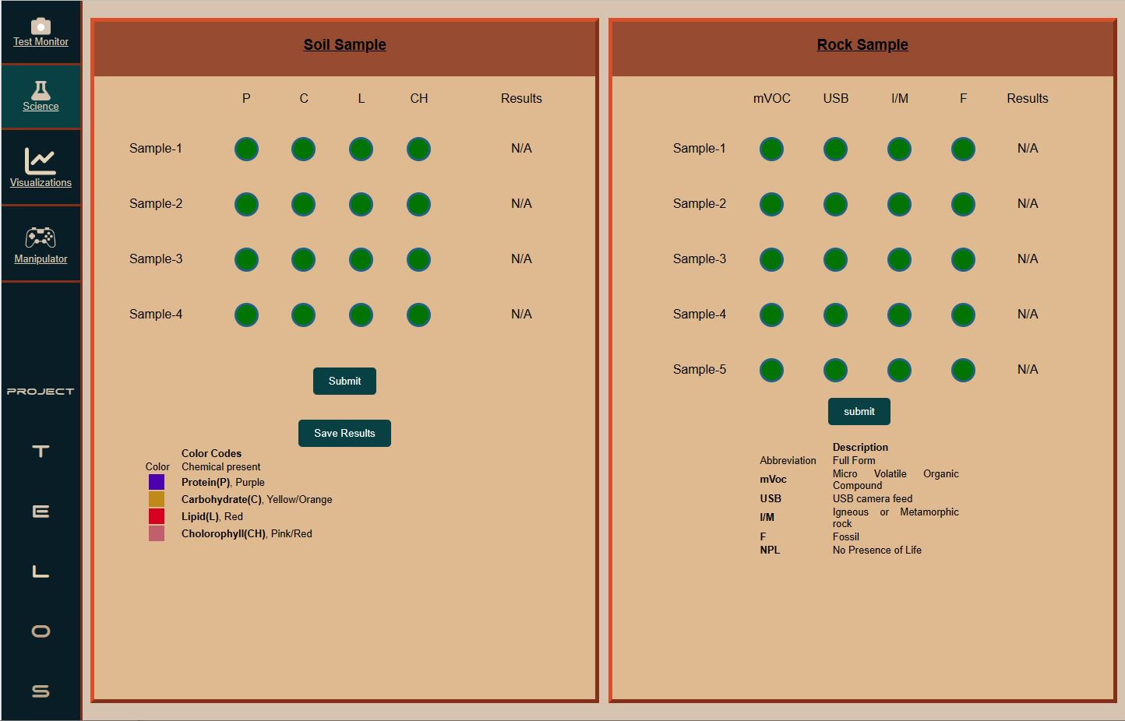

Every green circle on the dashboard turns light green whenever it is selected. When the submit button is pressed it saves a screenshot of the data as a PDF.

**Science Visualizations:**

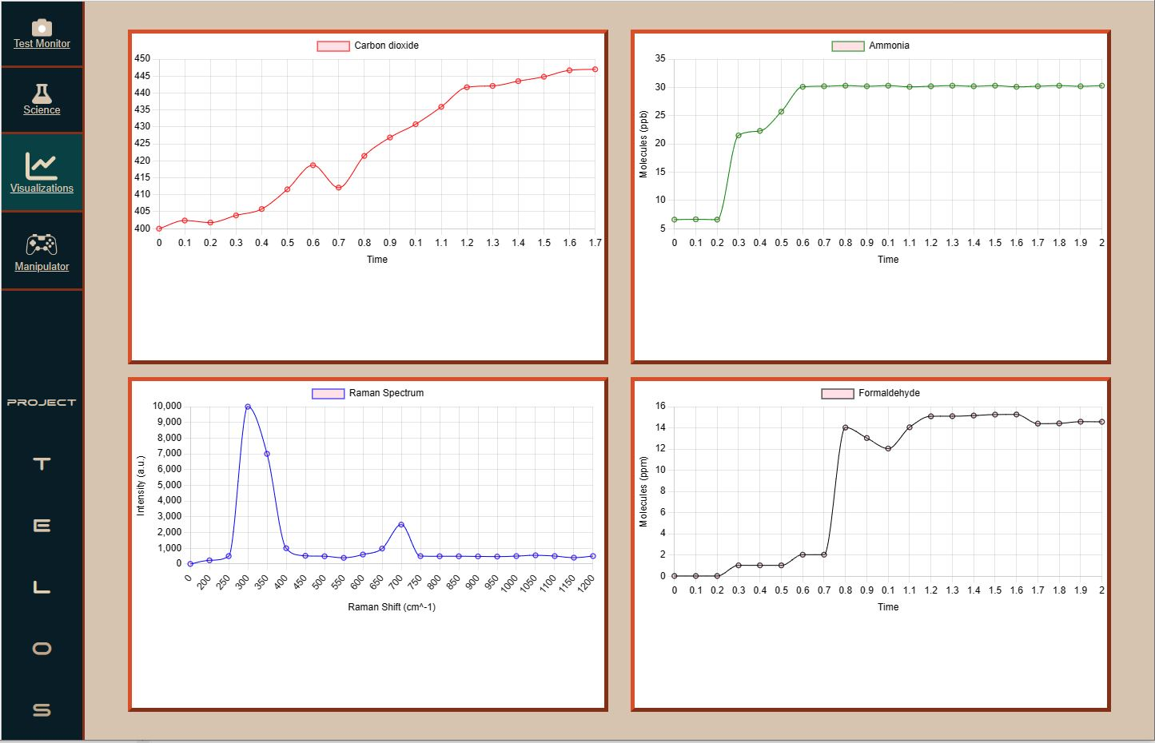

**Tips:**

1. Learn html,css quick [(click here)](https://www.youtube.com/watch?v=hu-q2zYwEYs&list=PL4cUxeGkcC9ivBf_eKCPIAYXWzLlPAm6G&index=1).
2. Understanding Flexbox makes things easier.

—-------------------------------------------------END—---------------------------------------------------